Wilson football bag
Price: Approximately Rs 30,999
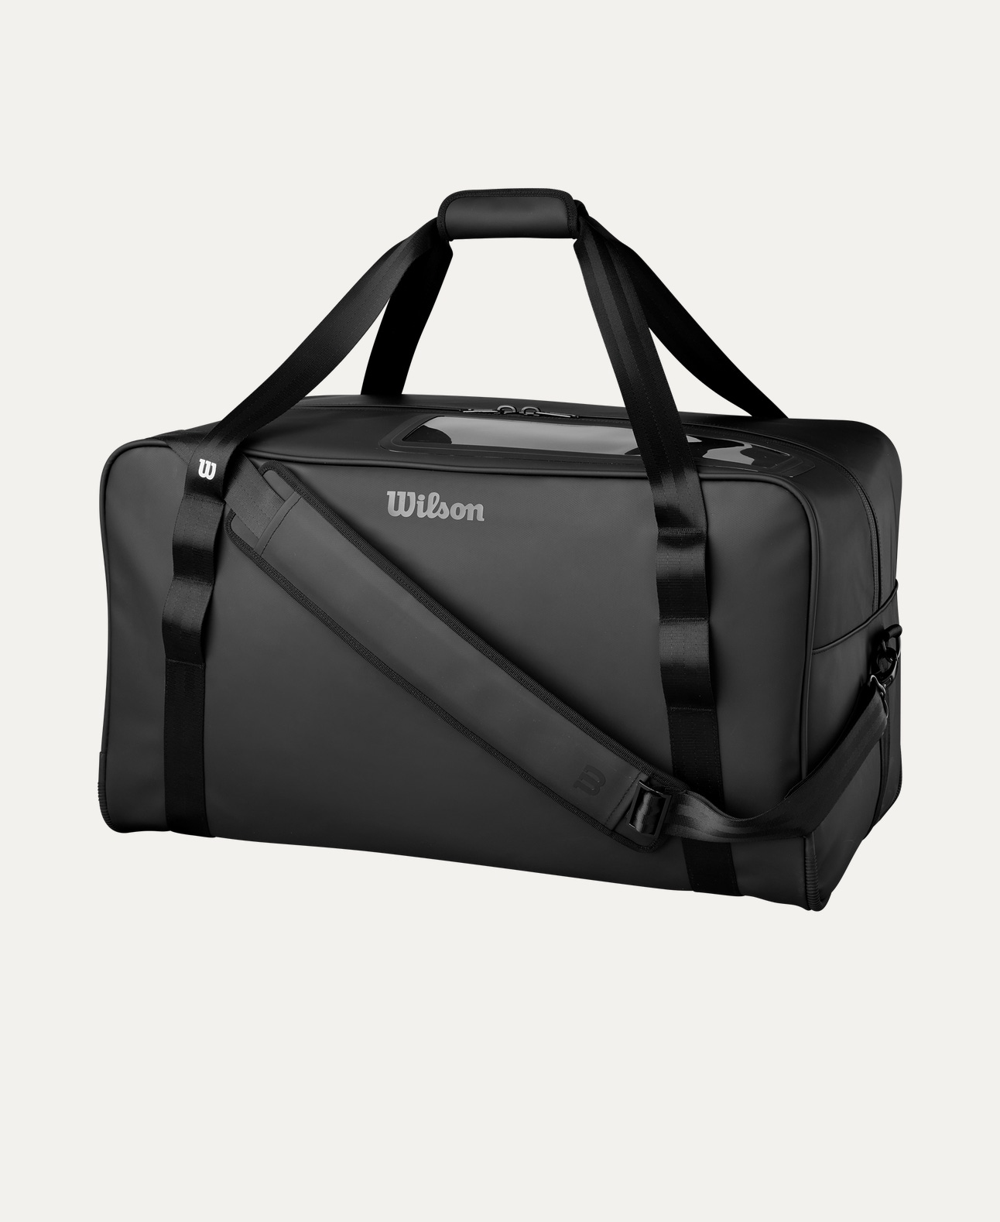
Introduction
The Wilson Football Bag is designed for easy transportation and organized storage of footballs. Built for durability and convenience, it is an essential accessory for teams, coaches, and training sessions.

Product Overview
This Wilson Football Bag provides ample space to carry multiple footballs securely. Its strong construction and practical design make it ideal for regular practice and match-day use.

About the Brand
Wilson is a world-renowned sports brand trusted by professional leagues, schools, and academies. Wilson bags are known for their strength, functionality, and long-lasting quality.

Key Features
- Large storage capacity for footballs
- Durable construction for daily use
- Easy-to-carry handles or shoulder strap
- Secure closure system
- Lightweight and practical design

Design & Build Quality
The bag features a simple yet sturdy design with reinforced stitching. Its structured shape helps keep footballs organized while allowing quick access during training.

Storage & Capacity
Designed to hold multiple footballs (capacity varies by model), making it suitable for team practices, tournaments, and sports events.

Material & Durability
Made from high-quality nylon or polyester mesh/fabric (model dependent), the Wilson Football Bag is built to withstand wear, moisture, and frequent handling.

Ideal For
- Football teams and clubs
- Coaches and trainers
- Schools and sports academies
- Practice sessions and match transport

Care Instructions
- Wipe clean with a damp cloth
- Air dry after use
- Do not overload beyond capacity
- Store in a dry place

Product Specifications
- Brand: Wilson
- Product Type: Football Bag
- Material: Nylon / Polyester
- Carry Type: Handle or Shoulder Strap
- Usage: Training & Match Transport

Product Summary
The Wilson Football Bag offers reliable storage, easy transport, and durable performance for football equipment. With trusted Wilson quality, it is a practical solution for keeping footballs organized and game-ready.
Thank you

